AI-SOC Assistant:

AI-Powered Security Alert Analysis and Incident Reporting System
Personal Cybersecurity & SOC Automation Project
Final Version: v4.8
Prepared By:
Huzaifa Waheed Khan
Software Engineering Student
University of Engineering and Technology (UET) Abbottabad
Technologies:
- Python
- Wazuh
- Google Gemini API
- REST APIs
- Threat Intelligence APIs
- JSON
- Git & GitHub
- Visual Studio Code
- Windows/Linux
- Python Virtual Environment (venv)
August 2026

TABLE OF CONTENTS

1. PROJECT OVERVIEW 4
2. PROJECT OBJECTIVES 5
3. PROBLEM STATEMENT 6
4. PROJECT SCOPE 7
5. TECHNOLOGIES USED 8
6. SYSTEM ARCHITECTURE 9
7. SYSTEM COMPONENTS 11
7.1 Parser 11
7.2 Alert Formatter 11
7.3 Threat Intelligence Manager 11
7.4 Risk Engine 11
7.5 Incident Classifier 11
7.6 Evidence Assessment 11
7.7 Context Builder 12
7.8 AI SOC Analysis 12
7.9 Report Generator 12
7.10 Main Pipeline 12
8. SYSTEM WORKFLOW 13
Step 1 — Alert Input 13
Step 2 — Alert Parsing 13
Step 3 — Alert Formatting 13
Step 4 — Threat Intelligence 13
Step 5 — Risk Assessment 13
Step 6 — Incident Classification 13
Step 7 — Evidence Assessment 13
Step 8 — Context Construction 14
Step 9 — AI SOC Analysis 14
Step 10 — Incident Report Generation 14
Step 11 — Report Storage 14
9. IMPLEMENTATION DETAILS 16
9.2 Main Application 17
9.3 Alert Parsing 17
9.4 Threat Intelligence 17
9.5 Deterministic Risk Engine 18
9.6 Evidence-Based Analysis 18
9.7 AI Analysis 18
9.8 Report Generation 18
10. TESTING AND VALIDATION 19
10.1 Alert Input Testing 19
10.2 Alert Formatting Testing 19
10.3 Threat Intelligence Testing 19
10.4 Risk Assessment Testing 19
10.5 Incident Classification Testing 19
10.6 Evidence Assessment Testing 19
10.7 AI SOC Analysis Testing 20
10.8 Report Generation Testing 20
10.9 End-to-End Validation 20
11. RESULTS AND OUTPUT 21
11.1 Sample Alert 21
12. LIMITATIONS AND FUTURE IMPROVEMENTS 31
12.1 Limitations 31
12.2 Future Improvements 31
13. CONCLUSION 32
14. REFERENCES 33
14.1 Cybersecurity and SOC References 33
14.2 Python References 33
14.3 AI / LLM Reference 33
15. APPENDICES 34

1. PROJECT OVERVIEW

AI-SOC Assistant is an independent personal cybersecurity project designed to demonstrate an evidence-based approach to Security Operations Center (SOC) incident analysis and reporting. The system processes security alerts, enriches the available alert information with cybersecurity knowledge, performs deterministic risk assessment, classifies the detected incident, evaluates the available evidence, and uses AI-assisted analysis to produce a structured SOC incident report.
The project focuses on the practical workflow followed during security alert investigation. Rather than relying solely on an AI model to determine the severity or conclusion of an incident, the system separates deterministic security processing from AI-assisted reasoning. Wazuh provides the security alert, while the application processes the alert through multiple analysis stages before generating the final incident report.
The finalized v4.8 architecture follows the pipeline:
Wazuh Alert → Parser → Alert Formatter → Threat Intelligence → Risk Engine → Incident Classification → Evidence Assessment → AI SOC Analysis → Incident Report
The system uses MITRE ATT&CK techniques associated with security alerts to provide additional cybersecurity context. Threat intelligence is applied where appropriate, including handling private internal IP addresses separately from publicly accessible IP addresses. A deterministic risk engine calculates the incident risk score using predefined factors such as Wazuh rule severity, IP classification, threat intelligence reputation, and associated MITRE techniques.
The evidence assessment stage separates confirmed information from suspicious observations and unconfirmed possibilities. This approach helps prevent the AI analysis from presenting assumptions as confirmed security events. The AI SOC analysis therefore works from the structured context produced by the preceding stages and provides an investigation-oriented interpretation, recommended actions, and a final SOC analyst conclusion.
The final output is a Markdown-based incident report containing the incident context, risk assessment, classification, evidence assessment, AI SOC analysis, and report information. Version v4.8 represents the finalized and frozen implementation of the project.

2. PROJECT OBJECTIVES

The main objective of the AI-SOC Assistant is to develop a practical, evidence-based system that assists with the analysis of security alerts and the generation of structured SOC incident reports.
The specific objectives of the project are:
- Process security alerts by loading and parsing Wazuh-formatted alert data.
- Format alert information into a clear and human-readable representation containing rule information, agent information, source IP, timestamp, MITRE IDs, and associated cybersecurity knowledge.
- Integrate MITRE ATT&CK knowledge to provide contextual information about techniques associated with security alerts.
- Perform threat intelligence analysis for applicable source IP addresses and distinguish between private internal addresses and publicly accessible addresses.
- Perform deterministic risk assessment using predefined security factors such as Wazuh rule severity, IP classification, threat intelligence reputation, and MITRE techniques.
- Classify security incidents according to their incident type, attack category, primary technique, and protocol.
- Assess available evidence by separating confirmed evidence, suspicious observations, and unconfirmed possibilities.
- Use AI-assisted SOC analysis to interpret the structured incident context while maintaining a clear distinction between confirmed facts and assumptions.
- Generate structured incident reports containing the incident context, analysis, severity, and investigation recommendations.
- Maintain an evidence-based analysis workflow that avoids claiming successful compromise, lateral movement, credential compromise, or other security events without supporting evidence.

3. PROBLEM STATEMENT

Security Operations Centers receive a large number of security alerts from monitoring and detection systems such as Wazuh. These alerts often contain technical information including rule identifiers, severity levels, source IP addresses, timestamps, and MITRE ATT&CK mappings. Manually reviewing this information and converting it into a structured incident assessment can be time-consuming and may lead to inconsistent analysis.
A further challenge is that a security alert does not necessarily prove that an attack or compromise was successful. For example, repeated SSH authentication failures may indicate password-guessing activity, but the alert alone does not confirm successful authentication, credential compromise, lateral movement, or host compromise. Therefore, an effective SOC analysis process must distinguish between confirmed evidence, suspicious observations, and unconfirmed possibilities.
The AI-SOC Assistant addresses this problem by providing a structured processing pipeline for security alerts. The system combines deterministic processing, MITRE ATT&CK contextualization, applicable threat intelligence, risk assessment, incident classification, evidence assessment, and AI-assisted analysis. The deterministic components establish the factual and risk-related context, while the AI component analyzes that structured context without replacing the underlying evidence.
The system ultimately converts a raw security alert into a structured SOC incident report containing the relevant alert information, threat intelligence status, risk assessment, incident classification, evidence assessment, AI-assisted analysis, investigation steps, remediation recommendations, and a final SOC conclusion.

4. PROJECT SCOPE

The scope of the AI-SOC Assistant is focused on the automated processing and analysis of security alerts within a SOC-oriented workflow. The finalized v4.8 implementation is designed to demonstrate how alert information can be transformed into structured security analysis and an incident report.
The system covers the following areas:
- Security Alert Processing — Loading and parsing Wazuh alert data provided to the system.
- Alert Formatting — Converting raw alert information into a readable security alert containing relevant rule, agent, source IP, timestamp, and MITRE information.
- MITRE ATT&CK Context — Providing cybersecurity knowledge for MITRE techniques associated with the alert.
- Threat Intelligence — Performing applicable IP reputation analysis while identifying private internal IP addresses for which public threat-intelligence lookup is not applicable.
- Risk Assessment — Calculating a deterministic risk score and assigning a corresponding risk level, incident status, and confidence level.
- Incident Classification — Categorizing alerts according to incident type, attack category, primary technique, and protocol.
- Evidence Assessment — Separating confirmed evidence, suspicious observations, and unconfirmed conditions.
- AI-Assisted Analysis — Providing SOC-oriented interpretation and recommendations based on the structured incident context.
- Incident Reporting — Generating and saving a structured Markdown incident report.
The project is intentionally limited to the finalized v4.8 architecture. It does not attempt to replace a complete enterprise SOC, perform autonomous incident response, or confirm compromise without supporting evidence. The AI component assists with analysis and reporting, while deterministic processing remains responsible for important security assessments.

5. TECHNOLOGIES USED

The AI-SOC Assistant was developed using a combination of programming technologies, cybersecurity tools, threat-intelligence services, and AI technologies.
Technology / Tool | Purpose
Python | Core programming language used to develop the SOC analysis pipeline.
Wazuh | Source of security alerts used as input for the analysis workflow.
MITRE ATT&CK | Provides contextual information about adversary tactics and techniques associated with alerts.
AbuseIPDB | Provides IP reputation and abuse-confidence information for applicable public IP addresses.
OpenRouter LLM | Provides AI-assisted SOC analysis based on the structured incident context.
JSON | Used for representing and storing sample security alert data.
Markdown | Used as the format for generated SOC incident reports.
Git / GitHub | Used for version control and maintaining project versions, including the finalized v4.8 state.
Visual Studio Code | Development environment used to write, organize, test, and manage the project.
Windows / PowerShell | Development and execution environment used during project implementation and testing.

6. SYSTEM ARCHITECTURE

The finalized AI-SOC Assistant follows a sequential SOC analysis pipeline in which each stage processes the output of the previous stage. The architecture separates alert processing, deterministic security assessment, evidence evaluation, and AI-assisted analysis to maintain an evidence-based workflow.

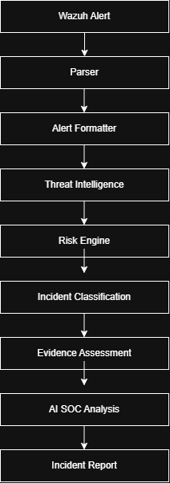

1. Wazuh Alert
Provides the initial security alert containing information such as the rule ID, rule level, description, agent, source IP, timestamp, and MITRE ATT&CK information.
2. Parser
Loads the alert data and converts the JSON alert into a Python data structure that can be processed by the remaining components.
3. Alert Formatter
Converts the alert information into a human-readable format and adds locally maintained MITRE ATT&CK cybersecurity knowledge.
4. Threat Intelligence
Analyzes applicable indicators, particularly source IP addresses. Private internal IP addresses are identified separately, while applicable public IP addresses can be checked through AbuseIPDB.
5. Risk Engine
Performs deterministic risk scoring using predefined factors such as Wazuh rule severity, IP classification, AbuseIPDB reputation, and associated MITRE techniques.
6. Incident Classification
Determines the incident type, attack category, primary MITRE technique, and protocol based on the available alert information.
7. Evidence Assessment
Separates information into confirmed evidence, suspicious observations, and unconfirmed possibilities. This prevents assumptions from being treated as confirmed security events.
8. AI SOC Analysis
Receives the structured incident context and performs AI-assisted SOC analysis. The AI provides interpretation, investigation steps, remediation recommendations, and a final conclusion while following the evidence-based requirements.
9. Incident Report
Combines the incident context and AI analysis into a structured Markdown report and saves it in the project's reports directory.

7. SYSTEM COMPONENTS

7.1 Parser
The parser is responsible for loading the Wazuh alert from a JSON file. It reads the alert using Python's JSON processing functionality and converts the stored alert into a Python dictionary. This provides the structured input required by the remaining stages of the SOC analysis pipeline.

7.2 Alert Formatter
The alert formatter converts the structured Wazuh alert into a human-readable security alert. It extracts rule information, agent information, source IP, timestamp, MITRE IDs, and MITRE tactics. It also incorporates locally maintained cybersecurity knowledge associated with the MITRE techniques present in the alert.

7.3 Threat Intelligence Manager
The Threat Intelligence Manager determines whether threat-intelligence analysis is applicable to the source indicator. It identifies the indicator type and handles private internal IP addresses separately because they are not applicable to public IP reputation platforms. For applicable public IP addresses, the system can use AbuseIPDB to obtain reputation information and an abuse-confidence score.

7.4 Risk Engine
The Risk Engine is a deterministic component responsible for calculating the security risk score. It evaluates predefined factors including Wazuh rule severity, source IP classification, AbuseIPDB reputation, and associated MITRE techniques. The resulting score is mapped to a risk level and accompanied by an incident status and confidence value.

7.5 Incident Classifier
The Incident Classifier categorizes the detected security event. It determines the incident type, attack category, primary MITRE technique, and protocol by evaluating information contained in the Wazuh alert.

7.6 Evidence Assessment
The Evidence Assessment component organizes the available information into three categories: confirmed evidence, suspicious observations, and unconfirmed conditions. This separation is an important part of the project's evidence-based approach because the presence of a security alert or an associated MITRE technique does not by itself prove that a successful attack or compromise occurred.

7.7 Context Builder
The Context Builder combines the outputs of the alert formatter, threat intelligence, risk engine, incident classifier, and evidence assessment into a structured incident context. This context becomes the input provided to the AI SOC analysis component.

7.8 AI SOC Analysis
The AI SOC Analysis component uses an OpenRouter-based large language model to analyze the structured incident context. It produces an executive summary, attack assessment, investigation steps, remediation recommendations, and a SOC analyst conclusion. The analysis is constrained by the supplied evidence and is instructed not to present unconfirmed events as established facts.

7.9 Report Generator
The Report Generator creates the final SOC incident report in Markdown format. The report combines the incident context and AI SOC analysis and stores the resulting report inside the project's reports directory.

7.10 Main Pipeline
The main application coordinates the complete processing sequence. It loads the alert, executes each analysis component in the defined order, displays the results in the console, generates the final AI-assisted analysis, and saves the resulting incident report.

8. SYSTEM WORKFLOW

The AI-SOC Assistant processes a security alert through a sequence of controlled analysis stages. Each stage contributes specific information to the next stage, resulting in a structured SOC incident report.

Step 1 — Alert Input
The system receives a Wazuh security alert containing information such as the rule ID, rule level, description, agent, source IP, timestamp, and MITRE ATT&CK information.

Step 2 — Alert Parsing
The parser loads the JSON alert and converts it into structured data that can be accessed by the application.

Step 3 — Alert Formatting
The alert formatter extracts the important alert fields and presents them in a human-readable format. Associated MITRE techniques are enriched with locally maintained cybersecurity knowledge.

Step 4 — Threat Intelligence
The source indicator is evaluated to determine whether threat-intelligence lookup is applicable. Private internal IP addresses are identified as internal indicators and are not submitted to public IP reputation platforms. Public IP addresses can be checked using AbuseIPDB.

Step 5 — Risk Assessment
The Risk Engine calculates a deterministic risk score using predefined security factors. The resulting score is converted into a risk level such as LOW, MEDIUM, HIGH, or CRITICAL.

Step 6 — Incident Classification
The alert is classified according to its incident type, attack category, primary technique, and protocol.

Step 7 — Evidence Assessment
The system separates the available information into Confirmed Evidence, Suspicious Observations, and Unconfirmed conditions. This ensures that an alert is not automatically treated as proof of compromise.

Step 8 — Context Construction
The Context Builder combines the alert, threat-intelligence results, risk assessment, incident classification, and evidence assessment into a structured context for AI analysis.

Step 9 — AI SOC Analysis
The structured context is provided to the AI analysis component. The AI generates a professional SOC assessment while following the evidence-based requirements defined by the system.

Step 10 — Incident Report Generation
The system combines the structured incident context and AI analysis into a Markdown incident report.

Step 11 — Report Storage
The generated report is saved inside the project's reports directory for later review and documentation.
Workflow Diagram Underneath:
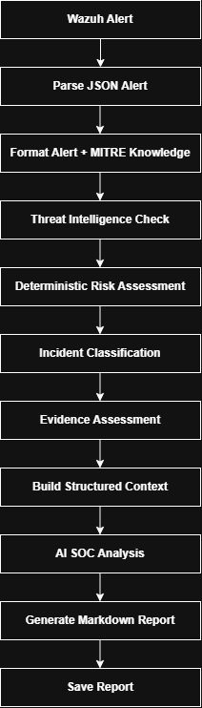

9. IMPLEMENTATION DETAILS

9.1 Project Structure

AI-SOC-Assistant/
│
├── app/
│ ├── abuseipdb.py
│ ├── ai.py
│ ├── alert_formatter.py
│ ├── config.py
│ ├── context_builder.py
│ ├── detector.py
│ ├── evidence.py
│ ├── incident_classifier.py
│ ├── ip_utils.py
│ ├── main.py
│ ├── mitre.py
│ ├── output.py
│ ├── parser.py
│ ├── prompts.py
│ ├── report.py
│ ├── risk_engine.py
│ ├── threat_rating.py
│ ├── ti_formatter.py
│ └── ti_manager.py
│
├── docs/
├── reports/
├── screenshots/
├── sample_alerts/
│ └── ssh_bruteforce.json
│
├── .env
├── .gitignore
├── LICENSE
├── README.md
└── requirements.txt

9.2 Main Application
The main.py module coordinates the complete SOC analysis workflow. It loads the alert, formats the alert information, obtains threat-intelligence information, calculates the deterministic risk assessment, classifies the incident, evaluates evidence, builds the AI context, performs AI-assisted analysis, generates the incident report, and saves the report.

9.3 Alert Parsing
The parser.py module provides the alert-loading functionality. It reads a JSON-formatted Wazuh alert using Python's JSON library and returns the resulting data structure for further processing.

9.4 Threat Intelligence
The threat-intelligence functionality is divided between the AbuseIPDB integration, IP classification, threat-intelligence management, and result formatting. The system first determines whether the source IP is private or public. Private internal addresses are identified as internal indicators and public threat-intelligence lookup is skipped. Applicable public IP addresses can be queried through AbuseIPDB.

9.5 Deterministic Risk Engine
The risk_engine.py module calculates the incident risk using predefined rules. The score is influenced by Wazuh rule severity, IP classification, AbuseIPDB reputation, and selected MITRE techniques. The final score is limited to a maximum of 100 and mapped to a corresponding risk level.

9.6 Evidence-Based Analysis
The evidence.py and context_builder.py modules support the evidence-based analysis approach. Confirmed facts are separated from suspicious observations and unconfirmed conditions before the information is provided to the AI analysis component.

9.7 AI Analysis
The ai.py module provides the AI-assisted SOC analysis functionality. The AI receives the structured incident context rather than an unstructured raw alert. The system prompt establishes requirements for evidence-based reasoning and prevents unsupported claims from being presented as confirmed facts.

9.8 Report Generation
The report.py module generates the final Markdown incident report. It includes an incident identifier, generation time, severity, incident context, AI SOC analysis, and report information. Generated reports are stored in the reports directory.

10. TESTING AND VALIDATION

Testing was performed to verify that the finalized AI-SOC Assistant pipeline operates correctly from alert input through incident report generation. The testing focused on validating individual processing stages as well as the complete end-to-end workflow.

10.1 Alert Input Testing
A sample SSH brute-force Wazuh alert was used to test the system. The alert was represented in JSON format and contained a rule ID, rule severity, description, agent information, source IP, timestamp, and MITRE ATT&CK information.

10.2 Alert Formatting Testing
The alert formatter was tested to verify that the relevant Wazuh fields were correctly extracted and displayed. MITRE technique IDs were also checked to ensure that the corresponding locally maintained cybersecurity information was included in the formatted alert.

10.3 Threat Intelligence Testing
Threat-intelligence processing was tested using the source IP 192.168.192.140. Because the address is a private internal IP address, the system correctly classified it as an internal address and skipped the public AbuseIPDB lookup.

10.4 Risk Assessment Testing
The deterministic risk engine was tested using the alert's rule severity, source IP classification, AbuseIPDB score, and MITRE techniques. For the tested alert, the system produced a risk score of 55/100, corresponding to a HIGH risk level. The incident status was reported as SUSPICIOUS with MEDIUM confidence.

10.5 Incident Classification Testing
The tested alert was classified as an SSH Brute Force incident under the Credential Attack category. The primary technique was identified as T1110.001 – Password Guessing, with SSH identified as the protocol.

10.6 Evidence Assessment Testing
The evidence assessment successfully separated the available information into confirmed evidence, suspicious observations, and unconfirmed conditions. The system explicitly identified that successful authentication, credential compromise, lateral movement, command execution, and host compromise had not been confirmed.

10.7 AI SOC Analysis Testing
The AI analysis was tested using the structured context generated by the previous processing stages. The resulting analysis provided an executive summary, attack assessment, investigation steps, remediation recommendations, and a SOC analyst conclusion. The analysis maintained the distinction between confirmed evidence and possible interpretations.

10.8 Report Generation Testing
The report-generation stage was tested to verify that the final incident report was successfully created in Markdown format and stored inside the reports directory. The generated report contained the incident context and AI SOC analysis.

10.9 End-to-End Validation

Test Area | Expected Result | Result
Alert Loading | JSON alert loaded successfully | PASS
Alert Formatting | Wazuh and MITRE information displayed | PASS
Private IP Detection | Internal IP identified correctly | PASS
Threat Intelligence | Public lookup skipped for private IP | PASS
Risk Assessment | Deterministic score generated | PASS
Incident Classification | SSH brute-force classification generated | PASS
Evidence Assessment | Evidence separated correctly | PASS
AI Analysis | SOC analysis generated | PASS
Report Generation | Markdown report created and saved | PASS

11. RESULTS AND OUTPUT

11.1 Sample Alert
The system was tested using a sample SSH brute-force Wazuh alert containing multiple SSH authentication failures from the internal source IP 192.168.192.140.

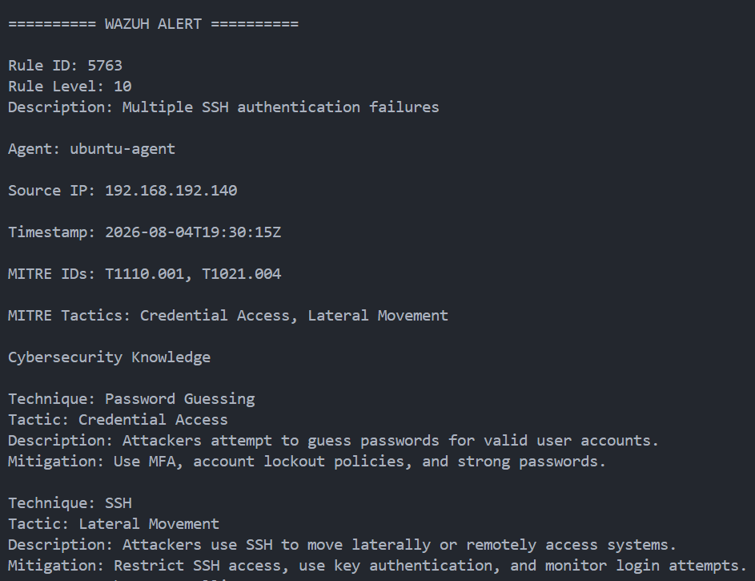
Figure 1: Sample Wazuh alert processed by the AI-SOC Assistant

11.2 Risk Assessment Result

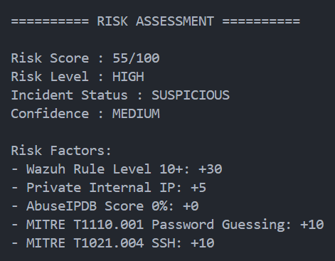
Figure 2: Deterministic risk assessment output

The deterministic Risk Engine assigned the tested alert a score of 55/100, resulting in a HIGH risk classification. The incident remained SUSPICIOUS, while the confidence level was MEDIUM.

11.3 Incident Classification Result

The system classified the alert as an SSH Brute Force incident under the Credential Attack category. The primary MITRE ATT&CK technique was identified as T1110.001 – Password Guessing, with SSH identified as the protocol.

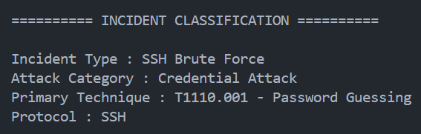
Figure 3: Incident classification output

11.4 Evidence Assessment Result

The Evidence Assessment stage separated the available information into confirmed evidence, suspicious observations, and unconfirmed conditions. This demonstrated the system's evidence-based approach and prevented unverified compromise claims from being treated as confirmed findings.

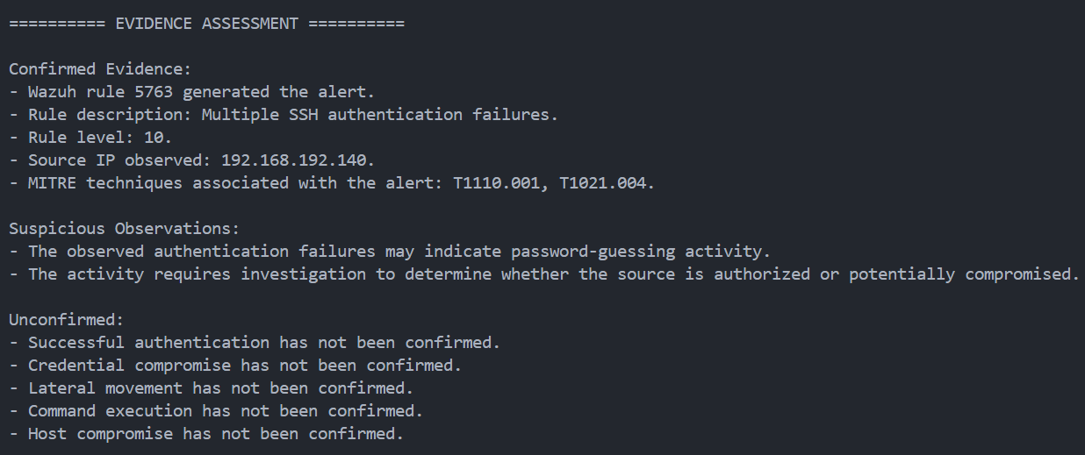
Figure 4: Evidence assessment output

11.5 AI SOC Analysis Result

The AI SOC Analysis produced an executive summary, attack assessment, investigation steps, remediation recommendations, and a final SOC analyst conclusion. The generated analysis maintained the distinction between confirmed observations and unconfirmed possibilities.

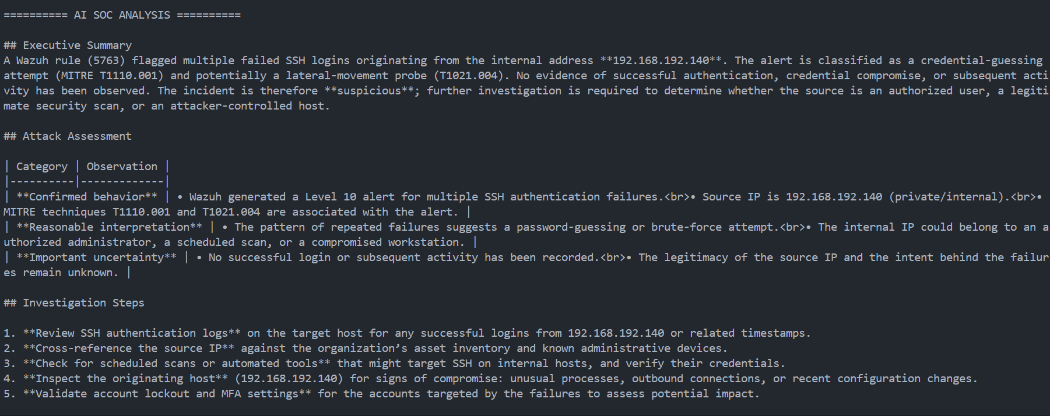
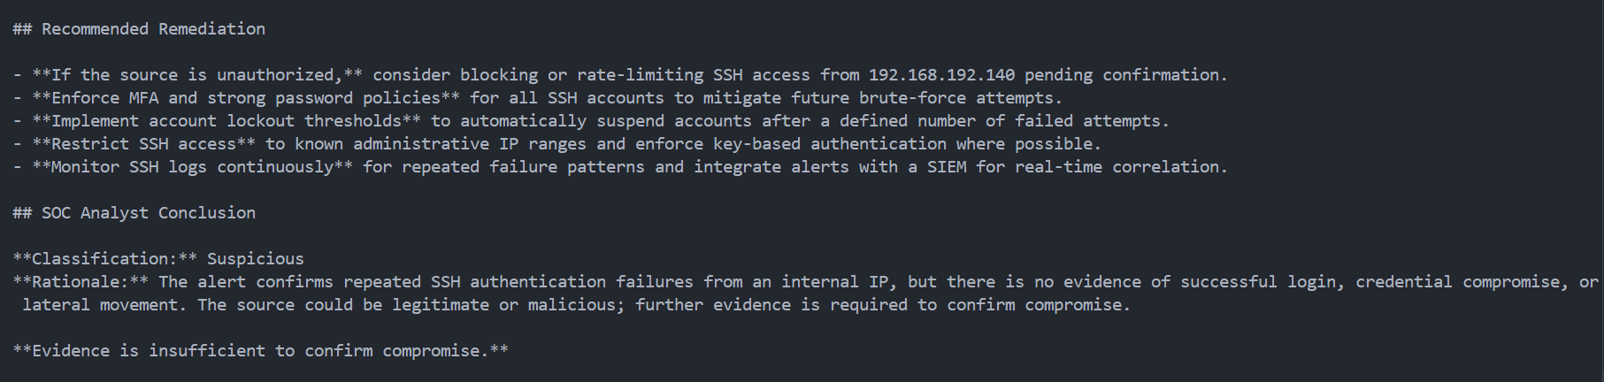
Figure 5: AI-generated SOC analysis

The AI SOC Analysis produced an executive summary, attack assessment, investigation steps, remediation recommendations, and a final SOC analyst conclusion. The generated analysis maintained the distinction between confirmed observations and unconfirmed possibilities.

11.6 Generated Incident Report

After completing the analysis pipeline, the system generated a Markdown-based incident report and stored it in the reports directory. The report combines the structured incident context with the AI SOC analysis and provides a documented representation of the investigated alert.

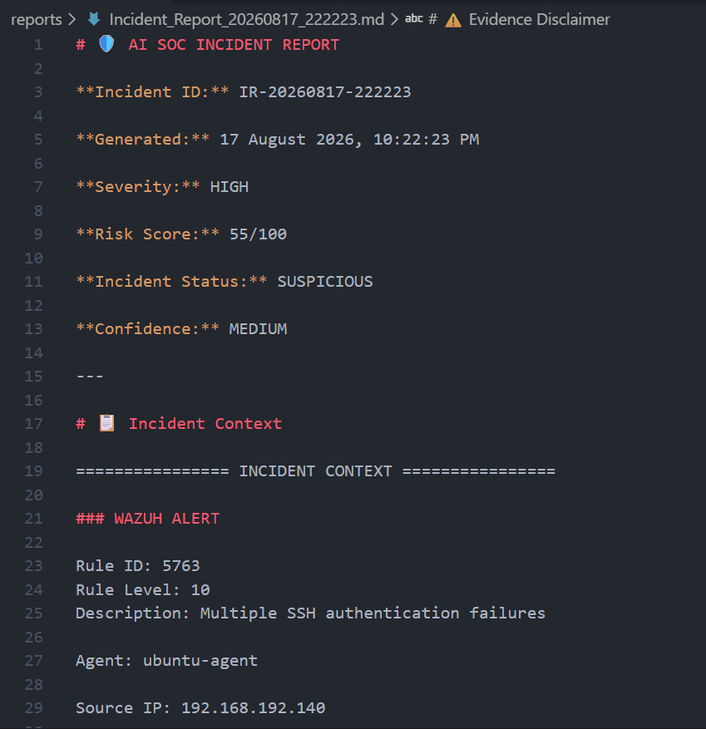
Figure 6: Generated SOC incident report

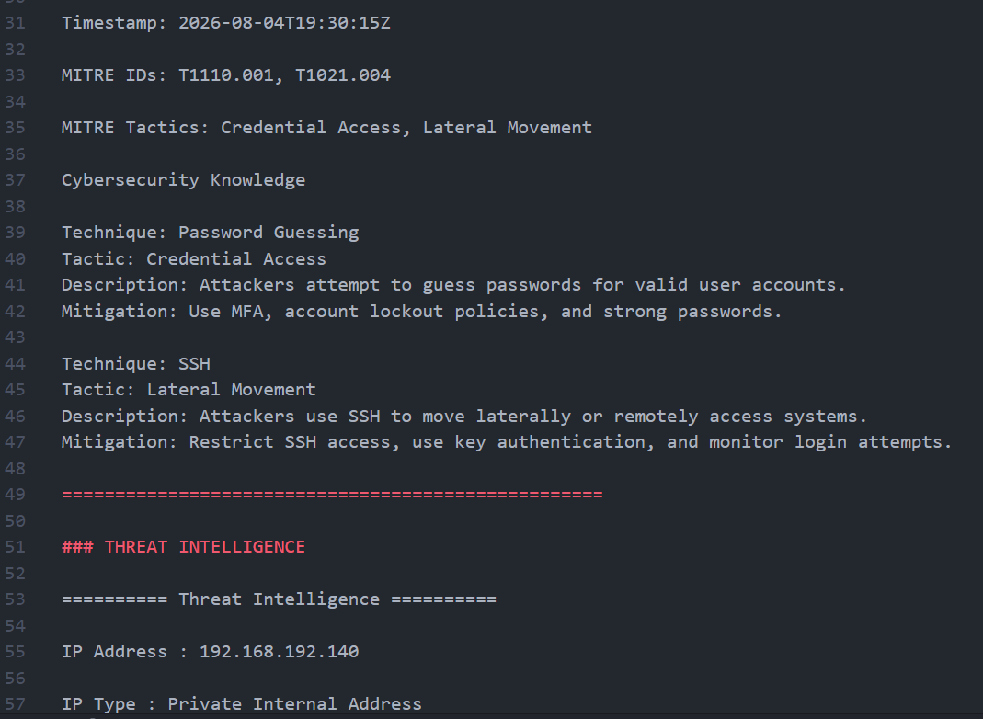
Figure 7: Generated SOC incident report

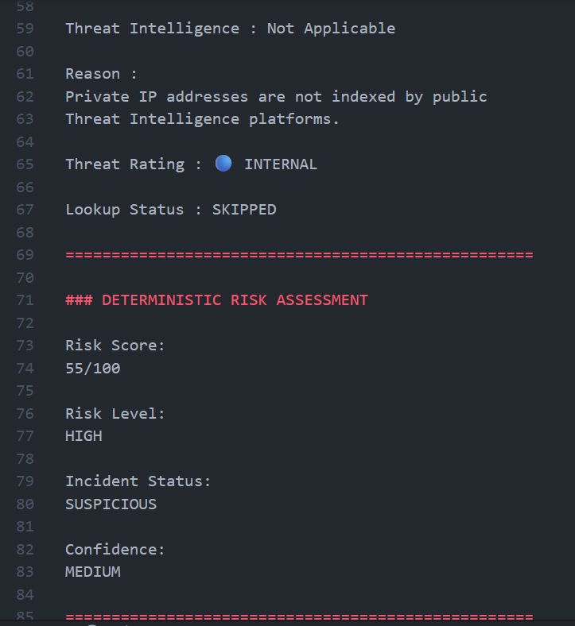
Figure 8: Generated SOC incident report

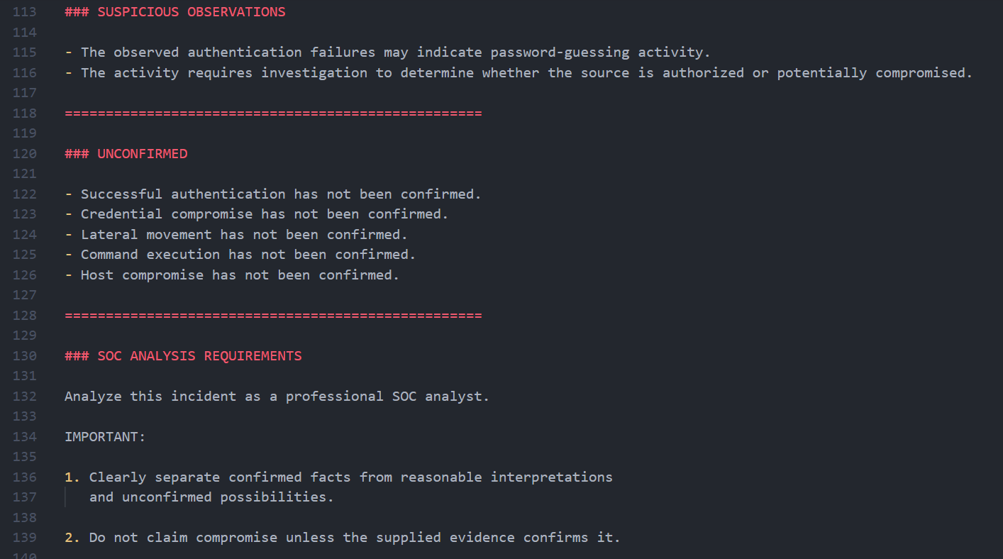
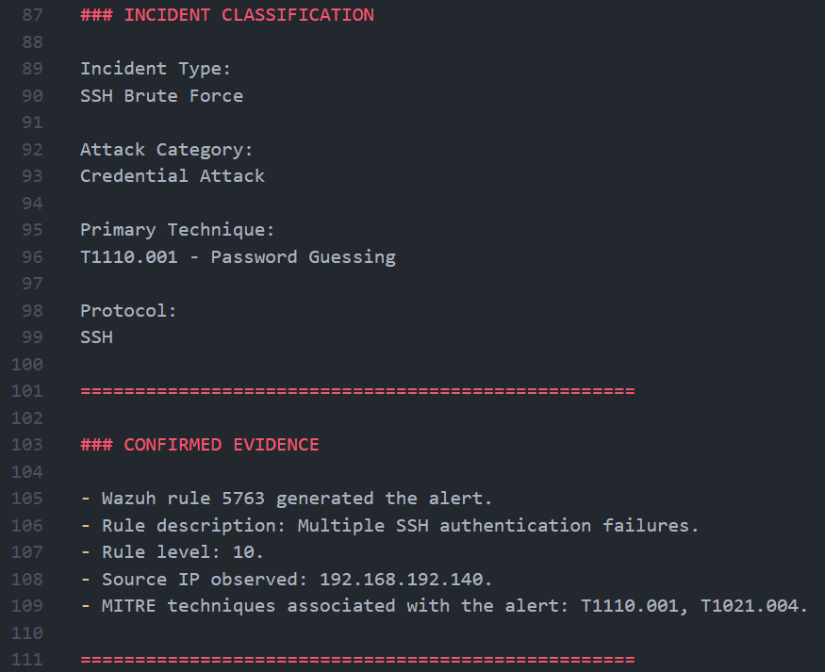
Figure 9,10: Generated SOC incident report
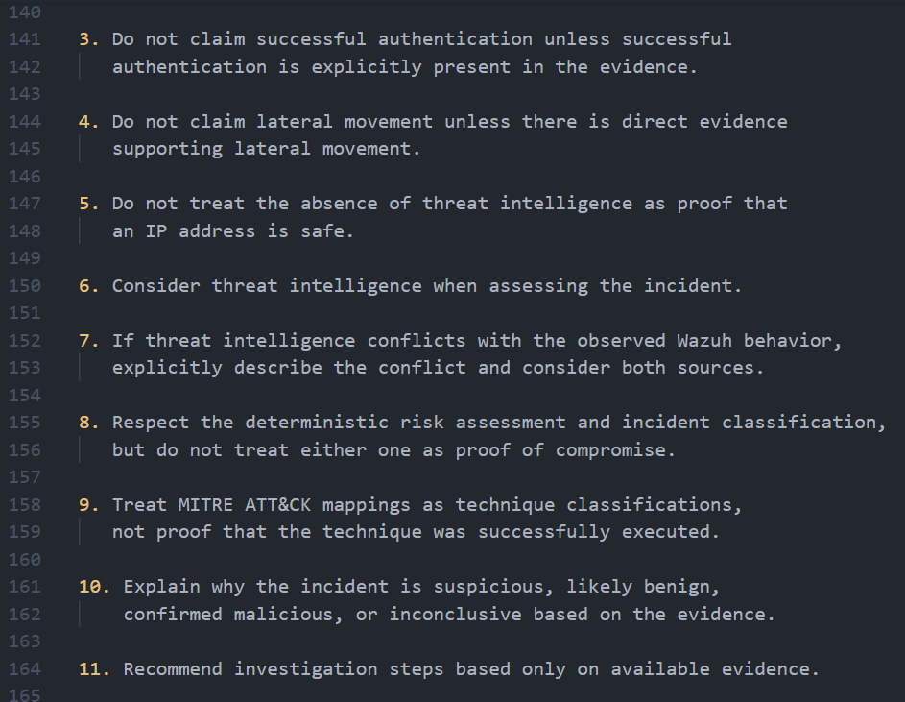
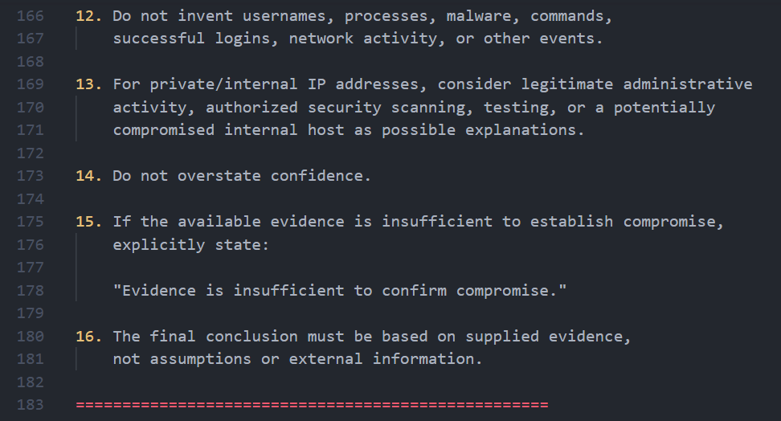
Figure 11,12: Generated SOC incident report

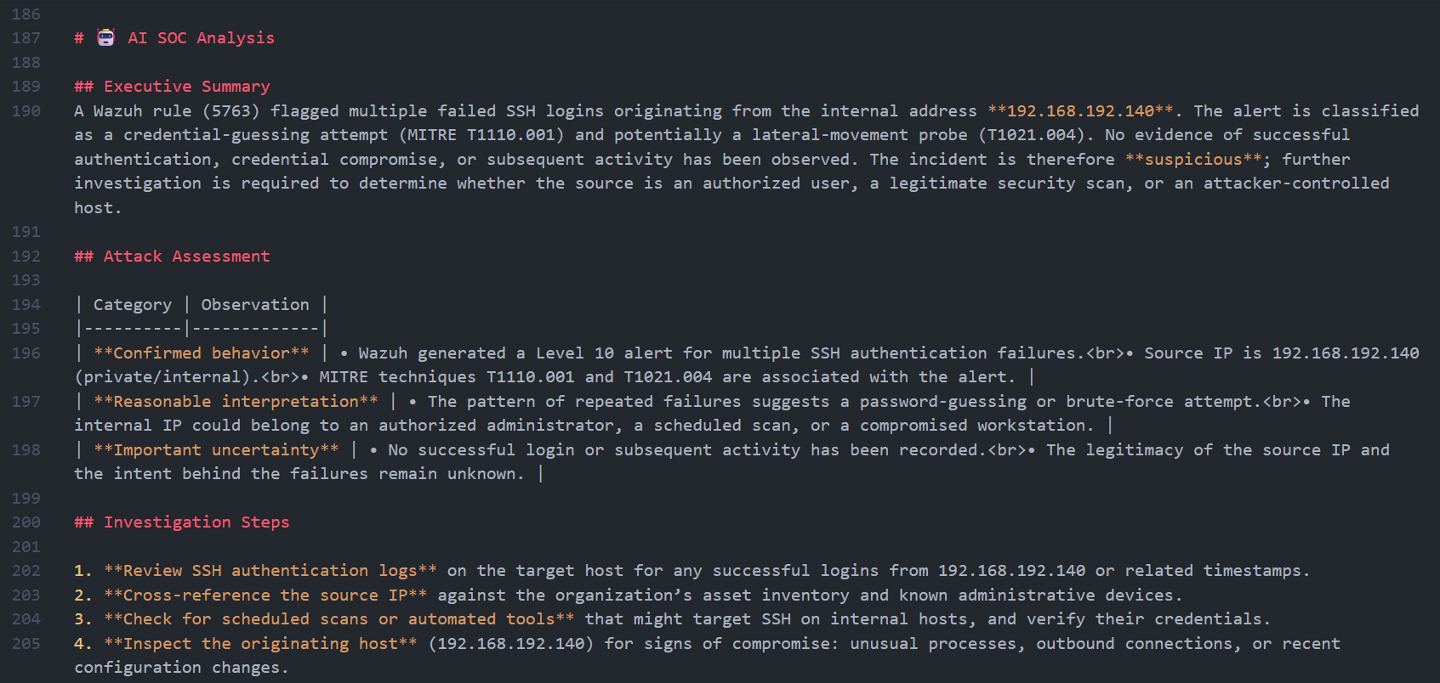

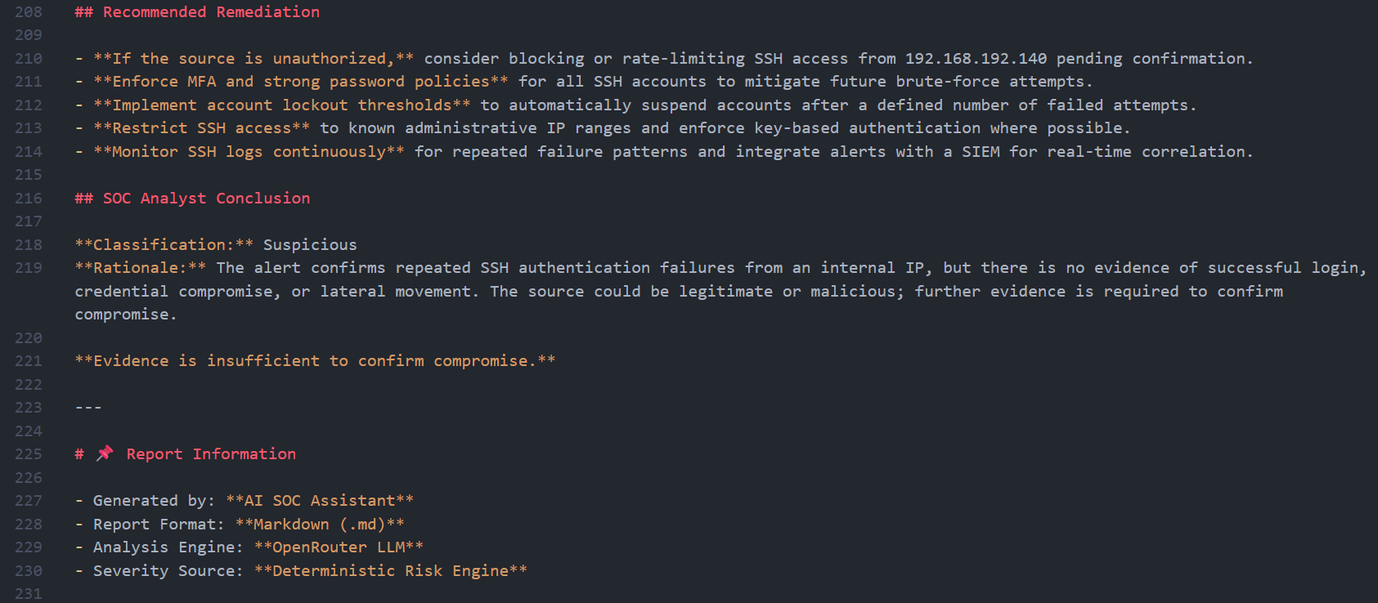
Figure 13,14: Generated SOC incident report

11.7 Overall Result
The testing demonstrated that the finalized v4.8 AI-SOC Assistant can process a structured Wazuh alert through the complete SOC analysis pipeline. The system successfully performed alert formatting, applicable threat-intelligence processing, deterministic risk assessment, incident classification, evidence assessment, AI-assisted analysis, and incident report generation.

12. LIMITATIONS AND FUTURE IMPROVEMENTS

12.1 Limitations
Although the AI-SOC Assistant provides a structured SOC analysis pipeline, the current implementation has several limitations.
First, the project processes structured Wazuh alert data and does not directly function as a complete enterprise SIEM deployment. The current testing therefore focuses on the alert-analysis pipeline rather than continuous production monitoring.
Second, threat intelligence availability depends on the applicable external service. Private internal IP addresses are not submitted to public IP reputation services such as AbuseIPDB, so their reputation cannot be determined through that source.
Third, the deterministic risk engine uses predefined scoring rules. Although this provides consistent and explainable results, the scoring model does not dynamically learn from historical incidents.
Fourth, AI-generated analysis depends on the quality and completeness of the evidence supplied to the AI component. The system therefore explicitly instructs the AI not to treat assumptions or MITRE technique associations as proof of successful malicious activity.
Finally, the current project is designed as a personal cybersecurity/SOC analysis project and has not been validated as a production enterprise SOC platform.

12.2 Future Improvements
Future versions could expand the project with additional capabilities such as integration with live Wazuh alert streams, broader threat-intelligence sources, historical incident correlation, analyst feedback mechanisms, automated case management, and more advanced visualization.
These improvements are outside the scope of the finalized v4.8 implementation. Version 4.8 was intentionally frozen as the completed project architecture, and additional feature modules are not part of the current implementation

13. CONCLUSION

The AI-SOC Assistant v4.8 project demonstrates the development of an evidence-based cybersecurity analysis pipeline designed to support SOC analyst activities. The system processes Wazuh security alerts through a structured sequence of alert parsing, alert formatting, applicable threat intelligence, deterministic risk assessment, incident classification, evidence assessment, AI-assisted analysis, and incident report generation.
A key design principle of the project is the separation between deterministic security analysis and AI-assisted reasoning. The Risk Engine provides a consistent and explainable risk assessment, while the AI component uses the structured evidence and context to produce a human-readable SOC analysis. This approach helps reduce unsupported conclusions and maintains a clear distinction between confirmed evidence, suspicious observations, and unconfirmed possibilities.
Testing with the SSH brute-force sample alert demonstrated that the finalized system can successfully process an alert and produce a structured SOC assessment. The tested alert received a risk score of 55/100, a HIGH risk level, and a SUSPICIOUS incident status. The system also classified the incident as SSH Brute Force and generated a corresponding incident report.
Overall, the project achieved its defined objectives for version v4.8 and provides a practical foundation for understanding SOC alert analysis, cybersecurity evidence assessment, deterministic risk scoring, threat intelligence integration, MITRE ATT&CK context, and AI-assisted security operations.
Version 4.8 represents the finalized and frozen implementation of the AI-SOC Assistant within the defined scope of this personal project.

14. REFERENCES

14.1 Cybersecurity and SOC References
- MITRE ATT&CK — MITRE ATT&CK knowledge base for adversary tactics, techniques, and mitigations.
- Wazuh Documentation — Wazuh documentation for security monitoring, alerts, rules, and detection capabilities.
- AbuseIPDB — IP reputation and abuse-reporting service used for applicable public IP threat-intelligence lookups.

14.2 Python References
- Python Documentation — Python language and standard-library documentation.
- Requests Documentation — Documentation for the Python HTTP library used for API communication.

14.3 AI / LLM Reference
- OpenRouter Documentation — Documentation for the LLM API interface used by the AI analysis component.

15. APPENDICES

Appendix A — Project Structure

AI-SOC-Assistant/
│
├── app/
│ ├── abuseipdb.py
│ ├── ai.py
│ ├── alert_formatter.py
│ ├── config.py
│ ├── context_builder.py
│ ├── detector.py
│ ├── evidence.py
│ ├── incident_classifier.py
│ ├── ip_utils.py
│ ├── main.py
│ ├── mitre.py
│ ├── output.py
│ ├── parser.py
│ ├── prompts.py
│ ├── report.py
│ ├── risk_engine.py
│ ├── threat_rating.py
│ ├── ti_formatter.py
│ └── ti_manager.py
│
├── docs/
├── reports/
├── screenshots/
├── sample_alerts/
│ └── ssh_bruteforce.json
│
├── .env
├── .gitignore
├── LICENSE
├── README.md
└── requirements.txt

Appendix B — Sample Wazuh Alert

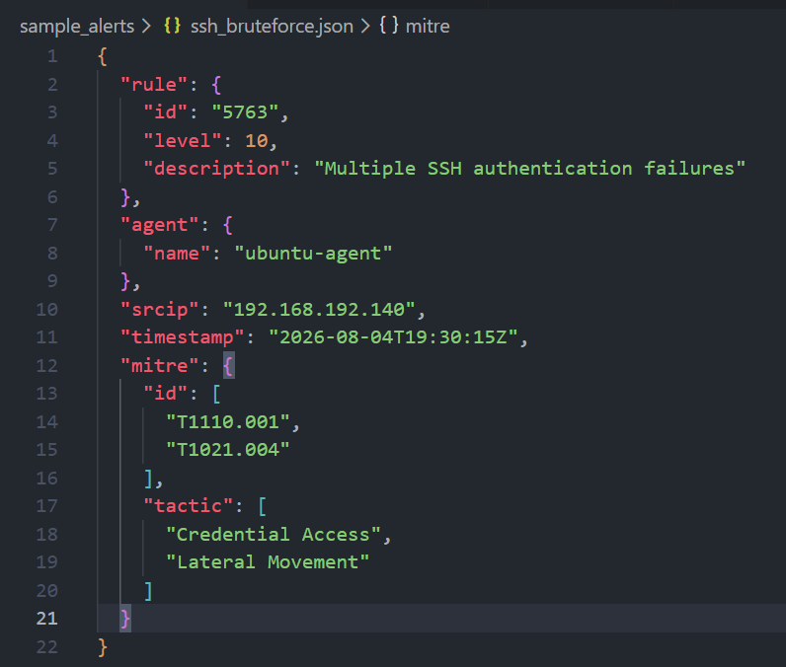
Figure 10: Sample Wazuh SSH brute-force alert used for system testing
Appendix C — Console Execution Output

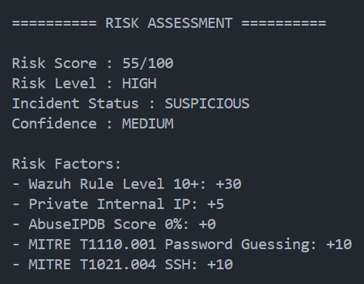
Figure 11: Complete end-to-end execution of the AI-SOC Assistant v4.8

Appendix D — Generated Incident Report



Figure 12: Generated SOC incident report

Appendix E — Git Versioning

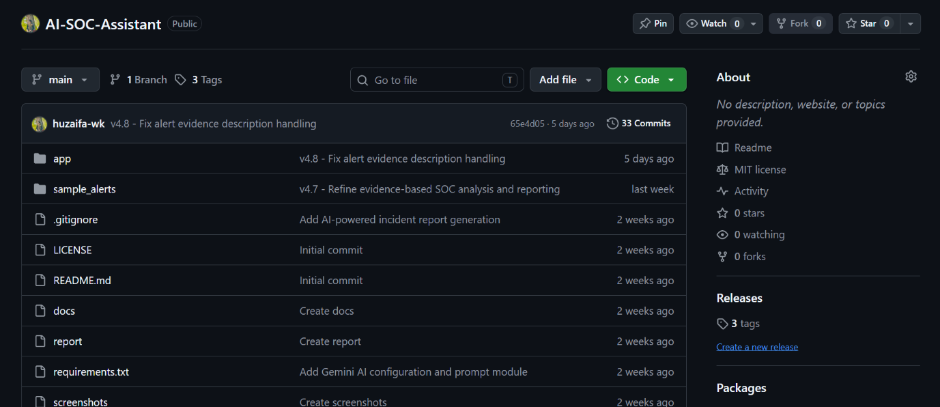

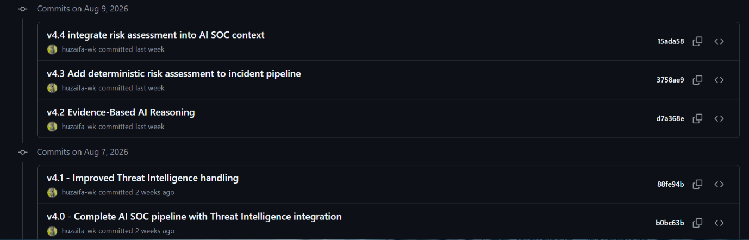

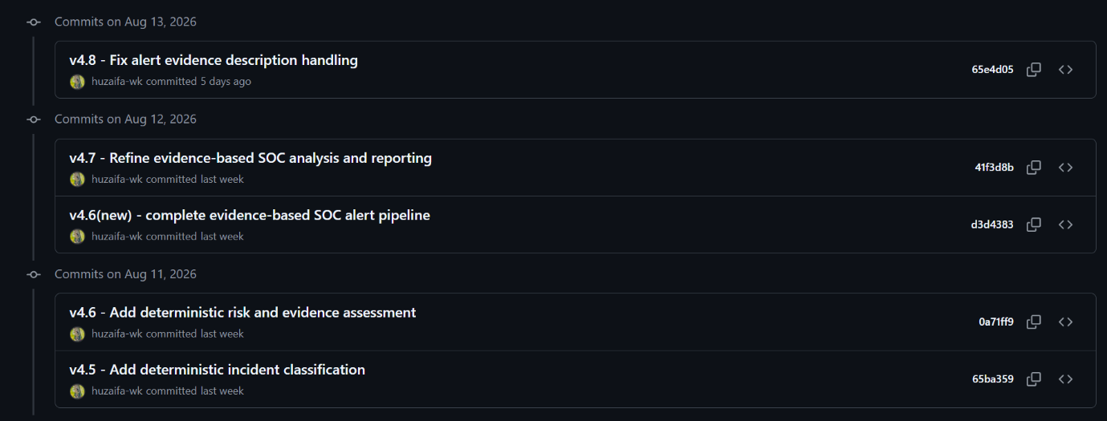
Figure 13: Git versioning and finalized v4.8 project state

